**Network Commands - Marking Scheme**

|  |  |  |  |  |
| --- | --- | --- | --- | --- |
|  | Registration  Number | Surname | Forename | % Contribution  (Out of 100) |
| Student 1 | 000839875 | Turon | Kacper | 25% |
| Student 2 | 000871936 | Young | Jack | 25% |
| Student 3 | 000878481 | Kallon | Kevin | 25% |
| Student 4 | 000874782 | Basharat | Usman | 25% |

|  |  |  |
| --- | --- | --- |
| **Task** | **Mark** | **Mark** |
| Task 1 - ipconfig / ifconfig -a | 15% |  |
| Task 2 - ipconfig /all | 15% |  |
| Task 3 - Address Problem | 15% |  |
| Task 4 - Ping and Graph | 20% |  |
| Task 5 - tracert / traceroute -I | 15% |  |
| Task 6 - Netstat | 20% |  |
| Total | 100 % |  |

COMP1587 Communication Systems

Laboratory 6

Network Commands

Usman Basharat - 000874782

Kevin Kallon - 000878481

Jack Young - 000871936

Kacper Turon - 000839875

Contents

Results 3

Task 1 - ipconfig / ifconfig –a 3

Task 2 - ipconfig /all 3

Task 3 - Address Problem 4

Task 4 - Ping and Graph 4

Task 5 - tracert / traceroute –I 5

Task 6 - Netstat 6

References 7

# Results

|  |  |  |  |
| --- | --- | --- | --- |
|  | Machine A | Machine B | UNIX |
| IPv4 Address | 193.60.73.204 | 193.60.73.114 | 193.60.76.235 |
| Subnet Mask | 255.255.255.0 | 255.255.255.0 | 255.255.255.0 |
| Default Gateway | 193.60.73.1 | 193.60.73.1 | - |
| Machine's IP Class | Class C | Class C | Class C |
| Machine's Network Address | 193.60.73.0 | 193.60.73.0 | 193.60.76.0 |
| Machine's Host Address | 193.60.73.255 | 193.60.73.255 | 193.60.76.255 |

## Task 1 - ipconfig / ifconfig –a

Table

## Task 2 - ipconfig /all

|  |  |  |
| --- | --- | --- |
|  | Machine A | Machine B |
| Host Name | KW116-032 | KW115-031 |
| Physical Address | 78-24-AF-89-B2-94 | 78-24-AF-89-B3-37 |
| NIC Manufacturer | 78-24-AF | 78-24-AF |
| IPv4 Address | 193.60.73.204 | 193.60.73.114 |
| Subnet Mask | 255.255.255.0 | 255.255.255.0 |
| Lease Obtained | 17 November 2015 09:23:43 | 17 November 2015 12:59:42 |
| Lease Expires | 24 December 2151 19:54:32 | 24 December 2151 19:50:15 |
| Default Gateway Address | 193.60.73.1 | 193.60.73.1 |
| DHCP Server Address | 193.60.48.8 | 193.60.48.8 |
| DNS Servers Addresses | 193.60.73.244; 193.60.77.254 | 193.60.73.244; 193.60.77.254 |
| Primary WINS Server Address | 193.60.52.230 | 193.60.52.230 |

Table

|  |  |  |  |  |  |  |
| --- | --- | --- | --- | --- | --- | --- |
|  | Machine A | | | Machine B | | |
|  | Network Class | Network Address | Host Address | Network Class | Network Address | Host Address |
| IPv4 Address | C | 193.60.73.0 | 193.60.73.255 | C | 193.60.73.0 | 193.60.73.255 |
| Default Gateway Address | C | 193.60.73.0 | 193.60.73.255 | C | 193.60.73.0 | 193.60.73.255 |
| DHCP Server Address | C | 193.60.48.0 | 193.60.48.255 | C | 193.60.48.0 | 193.60.48.255 |
| DNS Servers Addresses | C | 193.60.73.0;  193.60.77.0; | 193.60.73.255;  193.60.77.255; | C | 193.60.73.0;  193.60.77.0; | 193.60.73.255;  193.60.77.255; |
| Primary WINS Server Address | C | 193.60.52.0 | 193.60.52.255 | C | 193.60.52.0 | 193.60.52.255 |

Table

|  |  |  |
| --- | --- | --- |
| UNIX COMMAND |  | Address(es) |
| **netstat -rn** | Default Gateway Address | 193.60.76.1 |
| **cat /etc/resolv.conf** | DNS Servers Addresses | 193.60.49.84  193.60.48.13  193.60.48.9 |

Table

## Task 3 - Address Problem

|  |  |  |  |
| --- | --- | --- | --- |
|  | Computer 1 | Computer 2 | Computer 3 |
| IP Address | 192.168.12.113 | 192.168.12.205 | 192.168.112.97 |
| Subnet Mask | 255.255.255.0 | 255.255.255.0 | 255.255.255.0 |
| Default Gateway | 192.168.12.1 | 192.168.12.1 | 192.168.12.1 |

Table

All three of these computers use the same gateway: 192.168.12.1, so they access the same network using shared IP address. They also share the same subnet mask, 255.255.255.0. If permissions are set properly, they should be able to communicate to each other except from computer number 3, which is on different subnet 192.168.112.x instead of 192.168.12.x.

## Task 4 - Ping and Graph

|  |  |  |
| --- | --- | --- |
|  | Ping from Windows  Successful? | Ping from UNIX  Successful? |
| ping the IP address of a Windows computer  (IP: 193.50.73.114) | Yes | No |
| ping the IP address of a UNIX machine  (IP: 193.60.76.235) | Yes | Yes |
| ping the IP address of the default gateway  (IP: 193.60.73.1) | Yes | Yes |
| ping the IP addresses of a DNS server  (IP: 193.60.73.244 ; 193.60.77.254) | Yes | Yes |
| ping the Loopback IP address  (IP: 127.0.0.1) | Yes | Yes |
| ping the hostname of another computer  (hostname: KW116-032) | Yes | Yes |
| ping www.cisco.com | Yes | Yes |
| ping www.microsoft.com | Yes | Yes |

|  |  |  |
| --- | --- | --- |
|  | Command | Average Delay |
| Windows | Ping –n 5 –l 128 www.cisco.com | 2 ms |
| UNIX | Ping –s [www.cisco.com](http://www.cisco.com) 128 5 | 4.71 ms |

Table

|  |  |
| --- | --- |
| Packet Size | Average Time (s) |
| 250 | 3.556 |
| 500 | 3.672 |
| 1000 | 3.851 |
| 2000 | 4.27 |
| 4000 | 4.937 |
| 8000 | 6.145 |
| 16000 | 8.698 |

Table

Table

Figure

This shows that every time the packet size is increased, it takes longer to complete. The average number of pings we used were 10. We used [www.cisco.com](http://www.cisco.com) throughout each byte and we took the average from the result we received.

## Task 5 - tracert / traceroute –I

|  |  |  |  |  |  |
| --- | --- | --- | --- | --- | --- |
| Domain Name | IP addresses | Host Name | Network Address | Number of Hops -Windows | Number of Hops - UNIX |
| www.cms.gre.ac.uk | 193.60.72.1; 193.60.77.235 | cms-webserver.cms.gre.ac.uk | 193.60.72.0;  193.60.77.0 | 2 | 2 |
| staffweb.cms.gre.ac.uk | 193.60.72.1;  193.60.76.168 | staffweb.cms.gre.ac.uk | 193.60.72.0;  193.60.76.0; | 2 | 1 |
| www.gre.ac.uk | 193.60.72.1;  193.60.78.101 | gmwebsitevip.gre.ac.uk | 193.60.72.0;  193.60.78.0 | 2 | 2 |

Table

|  |  |  |  |  |  |
| --- | --- | --- | --- | --- | --- |
| Domain Name | IP addresses | Host Name | Network Address | Number of Hops -Windows | Number of Hops - UNIX |
| [www.amazon.com](http://www.amazon.com) | 54.239.17.6;  54.239.26.128 | www.amazon.com | 54.239.17.0;  54.239.26.0 | 30 | 30 |
| www.google.com.au | 173.194.67.94;  173.194.45.63 | www.google.com.au | 173.194.67.0;  173.194.45.0 | 13 | 13 |
| www.gov.hk | 68.232.34.73;  68.232.34.73 | dual46.gs1.wcp.v2cdn.net | 68.232.34.0;  68.232.34.0 | 10 | 10 |

Table

## Task 6 - Netstat

Table

|  |  |  |  |  |
| --- | --- | --- | --- | --- |
| Task | Windows Command | UNIX Command | Windows | UNIX |
| Show all active connections | netstat –a | netstat –a | - | - |
| Show all active TCP connections in numerical form | netstat -p tcp -n | netstat –f inet –n | - | - |
| Show all active TCP connections with Fully Qualified Domain Names for foreign addresses | netstat –p tcp -f | netstat –n | - | - |
| What are the number of IP packets received and sent since boot-up? How many were in error? | netstat –s –p ip | netstat -f inet -P ip -s | Packets Received:  6153511  Packet Sent:  4599557  Errors:  0 | Received: 3454099453  Packet sent: =3189353102  Errors: 0 |
| What are the numbers of IP packets sent and received in a typical 10 second interval? | netstat –s –p ip 10  CTRL + C on second display to stop | netstat -f inet -P ip -s 10  CTRL + C on second display to stop | Packets Received:  6256709  Packet Sent:  4600236  Errors:  0 | Received: 1420  Sent: 1320 |
| What are the numbers of TCP segments transmitted and received in a typical 20 second interval? How many retransmissions were there? | netstat –s –p tcp 20  CTRL + C on second display to stop | netstat -f inet -P tcp -s 20  CTRL + C on second display to stop  tcpInSegs and tcpOutSegs showed segments transmitted and received, tcpRetransSegs showed the number of segments retransmitted. | Received: 3570447  Sent: 2437852  Retransmission: 8776 | Received:  534  Sent:  335  Retransmitted:  0 |
| UDP datagrams - what are the numbers transmitted and received in a typical 20 second interval? | netstat –s –p UDP 20  CTRL + C on second display to stop | netstat -f inet -P udp -s 20  CTRL + C on second display to stop | Received : 913706  Sent: 425203  Errors : 0 | Received:  44  Sent: 54 |
| How many ICMP messages were sent and received in a typical 20 second interval? | netstat –s –p ICMP 20  CTRL + C on second display to stop | netstat -f inet -P icmp -s 20  CTRL + C on second display to stop | Received: 17  Sent: 19  Errors: 0 | Received: 3  Sent: 2  Errors: 0 |
| List the routing table entries | netstat –r | netstat –r | Refer to Figure 1.1 | Refer to Figure 1.2 |

**Windows**

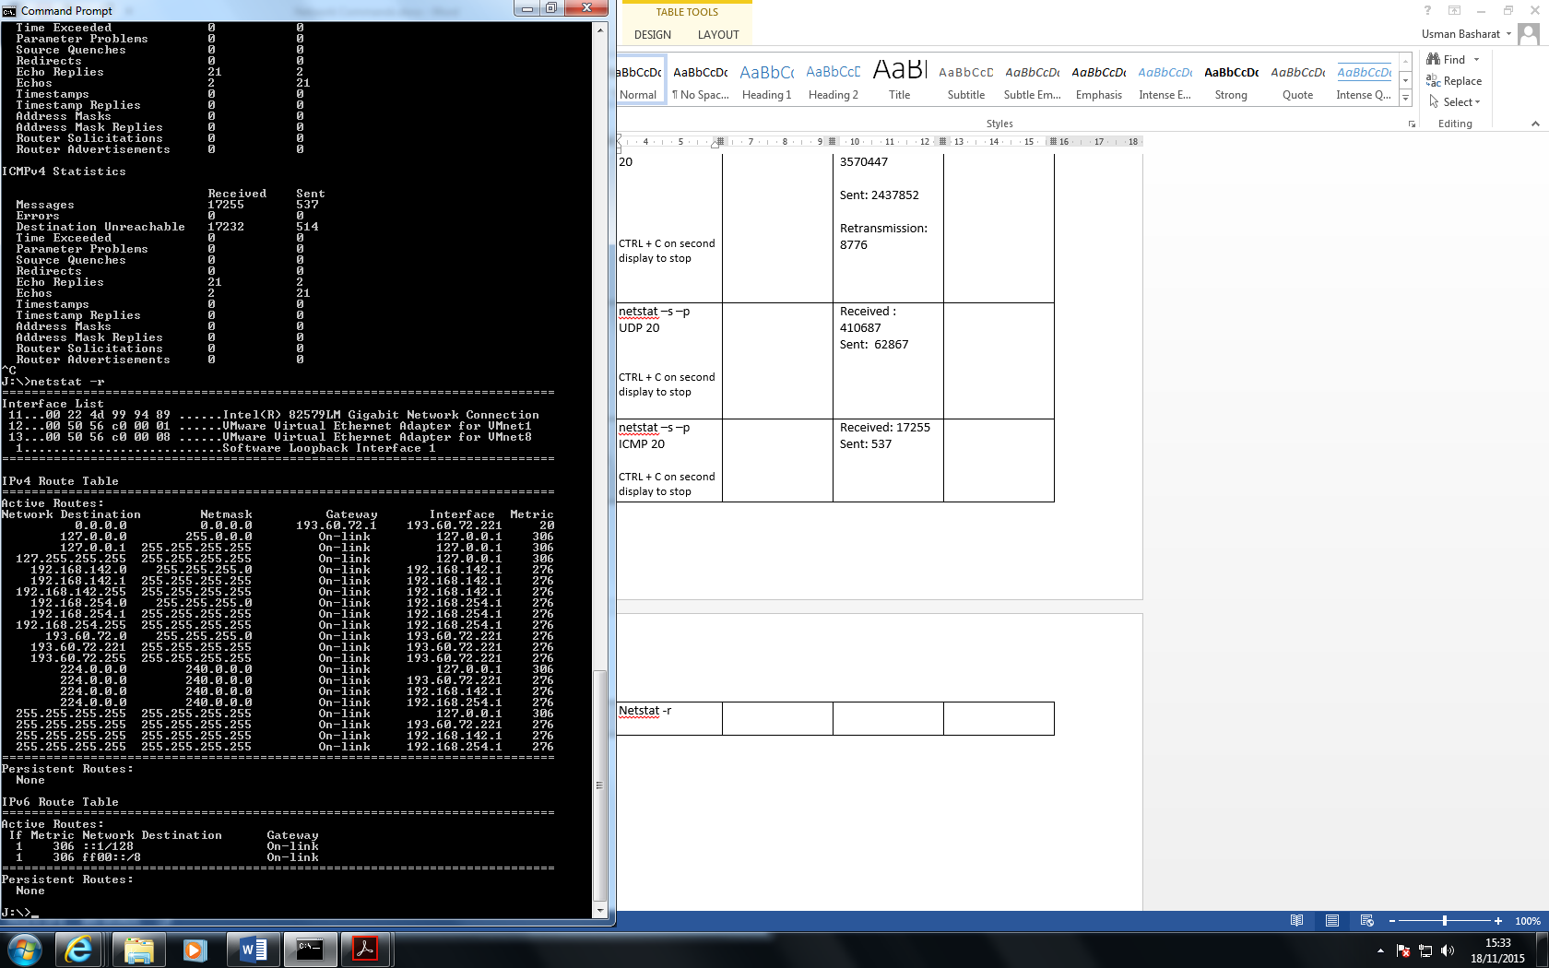

Figure 1.1

**UNIX**

# 

Figure 1.2

# References

Greenwich, University of. (2015) *Network Commands*, 1st ed, Greenwich, University of Greenwich, [online] Available at: <http://staffweb.cms.gre.ac.uk/~lg47/lectures/COMP1587/COMP1587Lab6.pdf>

(Accessed 18 November 2015).